July 7, 2026

Jarrett Lash
Community Development and Planning Officer
Upper Merion Township
175 West Valley Forge Road
King of Prussia, PA 19406

RE: Traffic Review #5 Response
Final Land Development Application
450 West Beidler Road
Parkview Homes at Valley Forge

Dear Jarrett:

SITE Engineering Concepts is pleased to submit the enclosed revision to the Land Development Plan application for the Parkview Homes at Valley Forge project at 450 West Beidler Road. This revision addresses the comments in Mr. Matthew Kozsuch’s May 8, 2026 review letter to Mr. Anthony Hamaday. The review comments are copied below in italics print. The response is set forth bold/non-italics print.

General
- A response letter must be provided with the resubmission detailing how each comment below has been addressed, and where each can be found in the resubmission materials (i.e., page number(s)) to assist in the re-review process. Additional comments may follow upon review of any resubmitted and more detailed plans during the land development process should the project receive conditional use approvals.
Response: This response letter accompanies the resubmission.
- As a reminder, since West Beidler Road (S.R. 3029) is a State Roadway, the applicant will be required to secure a PennDOT Highway Occupancy Permit (HOP) for the proposed driveway and work that may be completed within the legal right of way along West Beidler Road (S.R. 3029). The Township and our office must be copied on all HOP submissions, as well as correspondence between the applicant and PennDOT, PennDOT review letters, and invited to any and all meetings among these parties.
Response: The Township will be copied on all submissions.
- Please note, a separate letter will be transmitted by Boles Smyth Associates on behalf of the Upper Merion Transportation Authority to determine if an Act 209 assessment is required for this property.
Response: A letter was not received as we believe this property is not subject to Act 209.

Subdivision And Land Development Plan
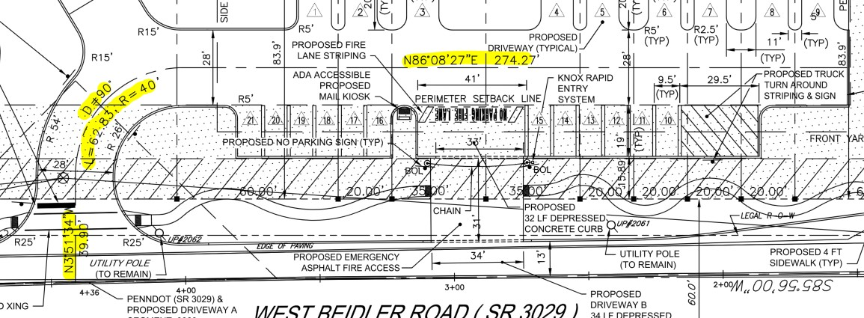
- As noted in our Review #5 letter, in accordance with Section 145-29.A.17 of the Subdivision and Land Development Ordinance, the Final Subdivision and Land Development Plan should include centerline geometry of all proposed streets (accesses), including radii and lengths of curves and tangent bearings, lengths of all straight lines, and angles. The previous 2022 plans included this information but are not shown on the current set. The applicant’s response letter notes that the data consistent with the previously approved plan per Resolution 2023-23 is shown on Sheets 14 and 17; however, we did not find the centerline geometry data on the revised plan. Revise accordingly. For ease of reference, below is a screenshot of the centerline data shown on the previously approved plan that needs to be shown on these revised plans:
Response: The data is added to the plan and profiles.
- The vehicle turning templates on the revised plans reflect a SU-30 single unit vehicle utilizing the emergency access for inbound and outbound movements. Revise the plans to show these movements being made from the main access and demonstrate they are able to turnaround within the back of the site.
Response: The SU-30 is added to the Main drive turning template with the front-loaded dumpster. The vehicle used for the emergency access turning template is the UMT Tower Ladder 47.
- With respect to the proposed emergency access:
  - There is a sign shown on the southeast corner of the access, but the sign type is not identified; however, sign the access with “Emergency Vehicles Only” signs on both sides of the access.
Response: The sign is labeled and detail added.
  - On the site side of the access, Inlet PI-4 is shown as a Type ‘C’ inlet top. Verify this inlet type is correct given its’ location adjacent to the median and adjacent to the depressed curb opening. A Type ‘M’ inlet may be more appropriate.
Response: The Type C inlet will be rotated 90 degrees so that the throat is along the island curb, allowing the taper to full height from the depressed emergency drive.
  - Revise the ADA ramps on either side of the proposed emergency access to include rolled flares.
Response: Roller flares are added.
  - A profile for the emergency access has been provided as requested; however, revise the profile to label the proposed slopes for each driveway section. In addition, label the proposed elevations at each of the grade breaks.
Response: The slopes and elevations are added as requested.
- As a reminder, approval from the Fire Marshal must be secured for this application. Any associated review documentation that has been received and addressed should be included in future submissions.
Response: Acknowledged.

We trust these revisions will satisfactorily address your comments. Should you have any questions and/or additional comments, please contact me at pspellman@site-engineers.com or 610.523.9002.

Sincerely,
Patrick Spellman, P.E.

